Grid Configuration:-

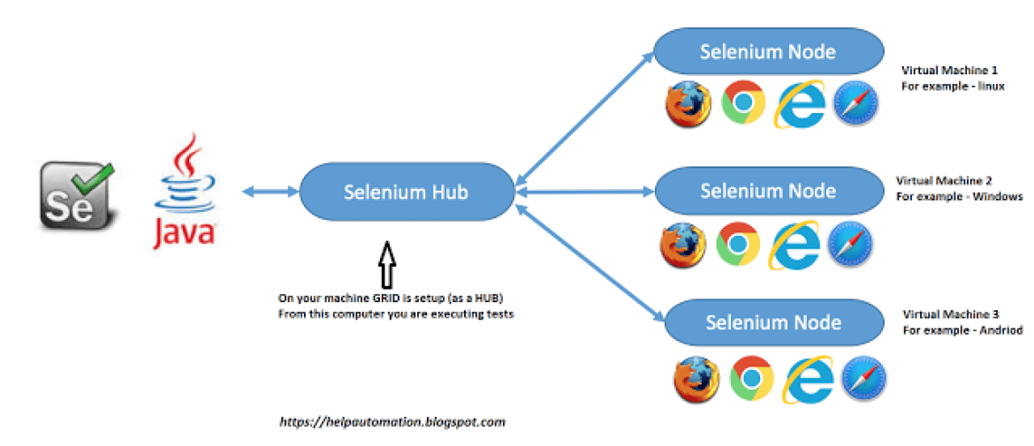

Register hub

Navigate till selenium stand alone server folder

Then run command

java –jar selenium-server-standalone-3.141.59.jar -role hub

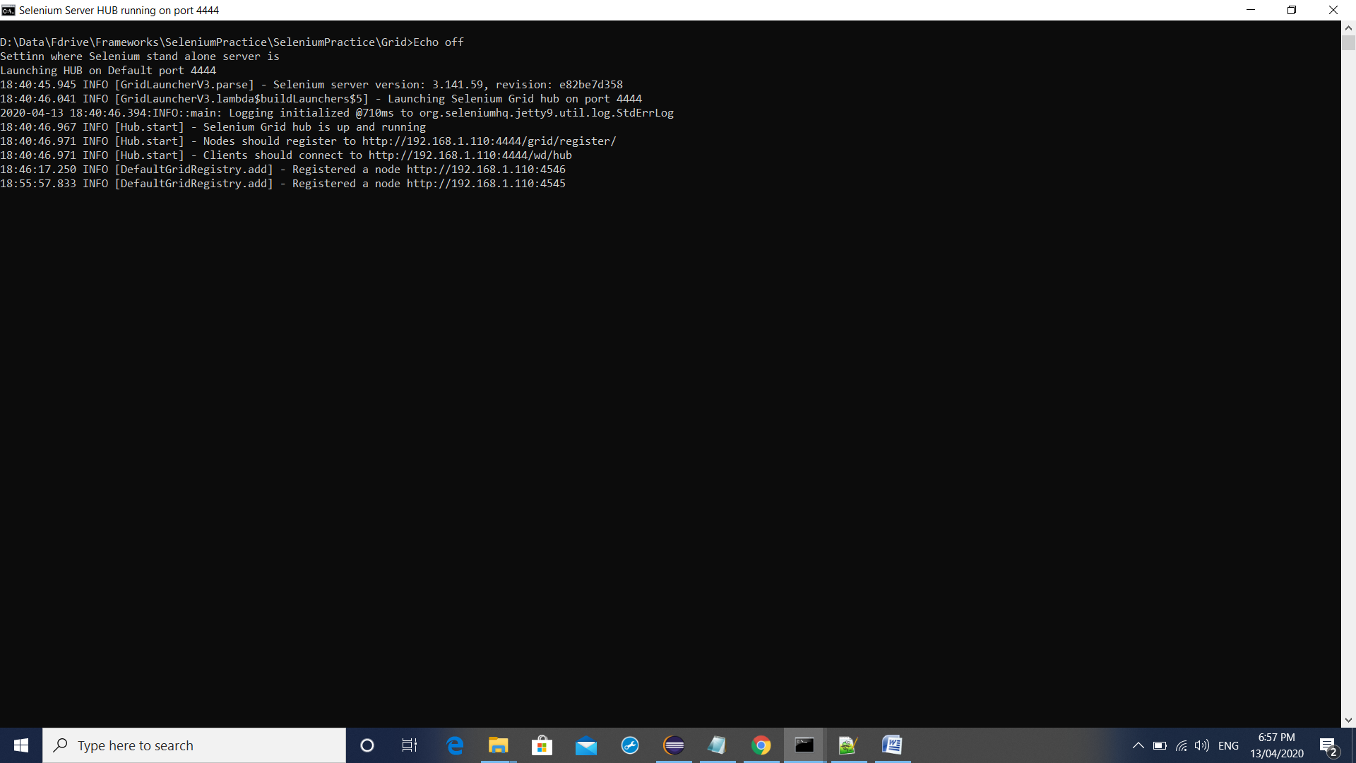

Now register node

Open another command prompt

java -Dwebdriver.chrome.driver=D:\Data\Fdrive\Frameworks\SeleniumPractice\SeleniumPractice\Grid\chromedriver.exe –jar selenium-server-standalone-3.141.59.jar -role node –hub http://localhost:4444/grid/register/ -port 4546

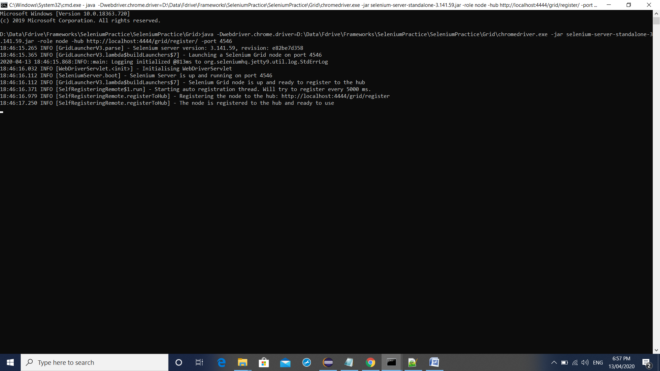

java -Dwebdriver.gecko.driver=D:\Data\Fdrive\Frameworks\SeleniumPractice\SeleniumPractice\Grid\geckodriver.exe –jar selenium-server-standalone-3.141.59.jar -role node –hub http://localhost:4444/grid/register/ -port 4545

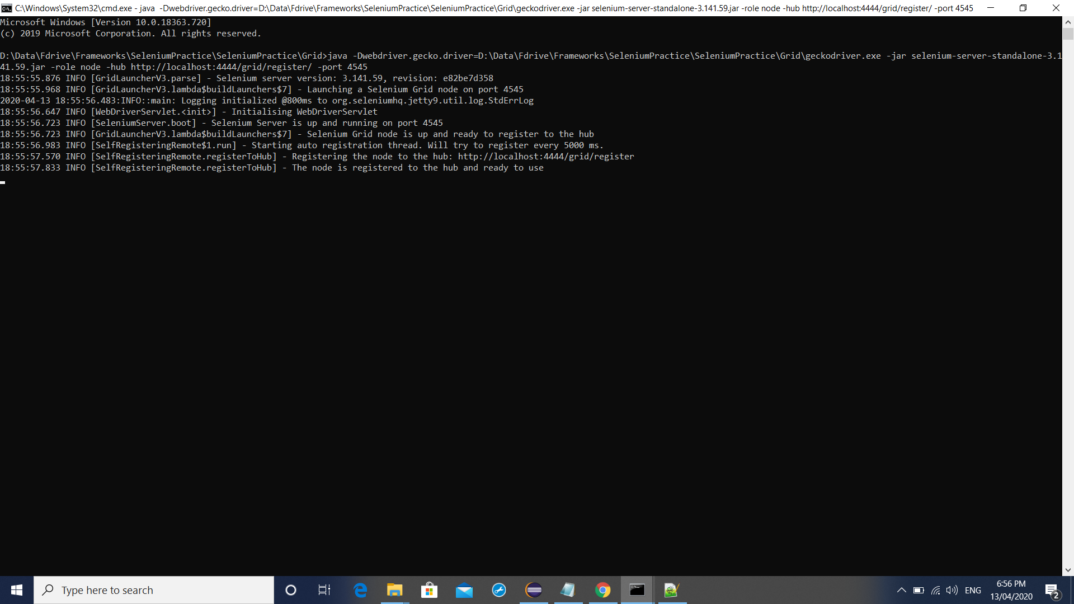

Chek whether it is registered or not

<http://localhost:4444/grid/console>

<http://192.168.1.110:4444/grid/register/>